[使用指南(PX4) · C-RTK系列GNSS (cuav.net)](https://doc.cuav.net/gps/c-rtk-series/zh-hans/c-rtk2-hp/users-manual-px4.html)

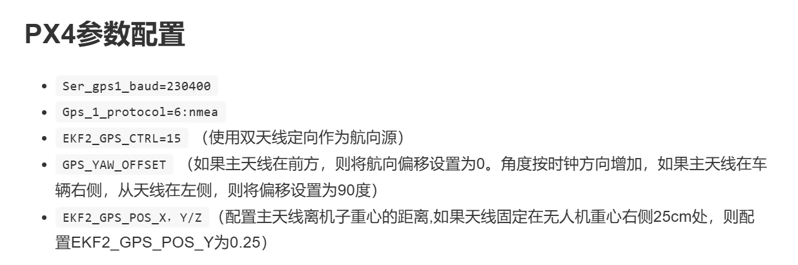

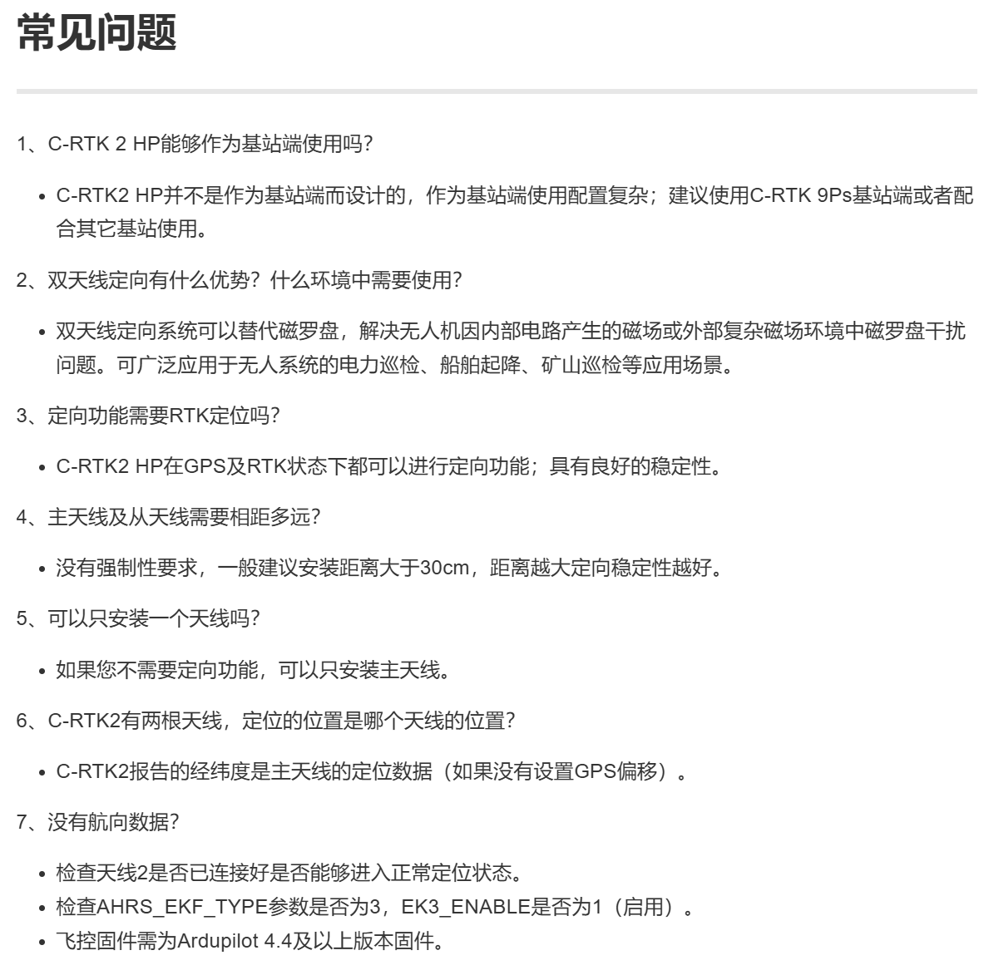

官方：[购买 Holybro H-RTK Unicore UM982 GPS |PX4 指南（主）](https://docs.px4.io/main/zh/gps_compass/rtk_gps_holybro_unicore_um982.html)